Practical 09 : Project Management Tool(Tiaga.in)
Taiga is a project management platform for agile developers & designers and project managers who want a beautiful tool that makes work truly enjoyable.

Powerful

Customize everything. Easily. You are in full control.

Simple & Intuitive

Figuring out the tool is ridiculously easy.

Highly Designed

Simple & Gorgeous! Beautiful to look at all day long.

Customizable

Give each project its own personality.

Scrum

Scrum is an iterative and incremental agile software development methodology for managing product development.
The product backlog is what will ultimately be delivered, ordered into the sequence in which it should be delivered. Product Backlogs are broken into manageable, executable chunks named sprints. Every certain amount of time the team initiates a new sprint and commits to deliver a certain number of user stories from the backlog, in accordance with their skills, abilities and resources. The project advances as the backlog becomes depleted.
Login Page:
First do registration and then login to tool.

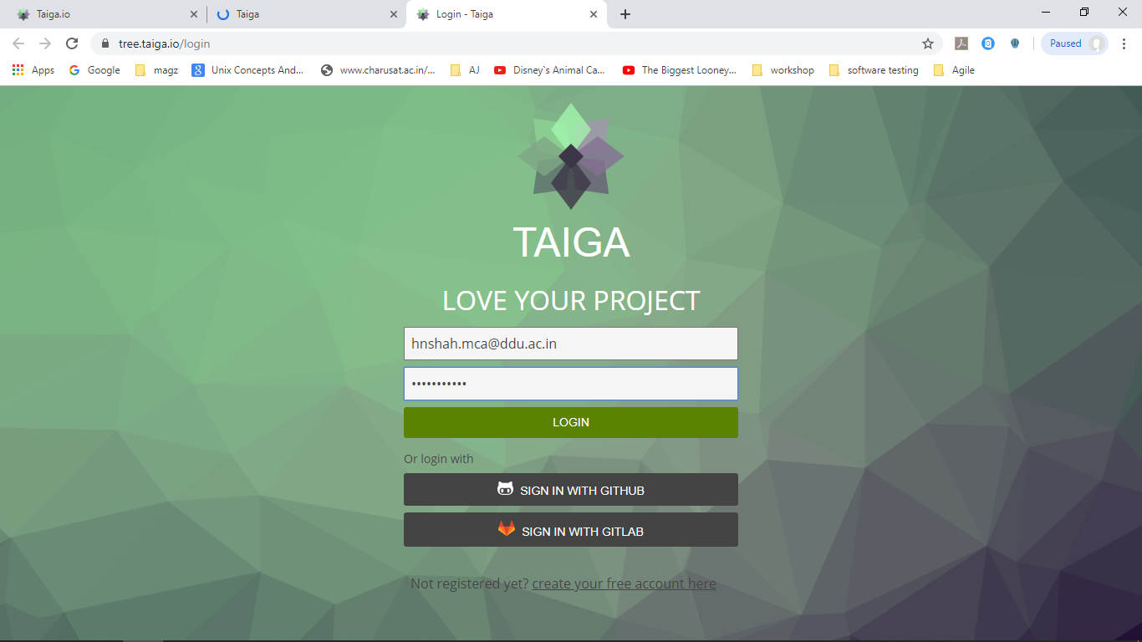

Main Page:
it will display project dashboard which contains information of all project with its details. it shows other user profile menu , create and edit project menu, and notifications of other team members.

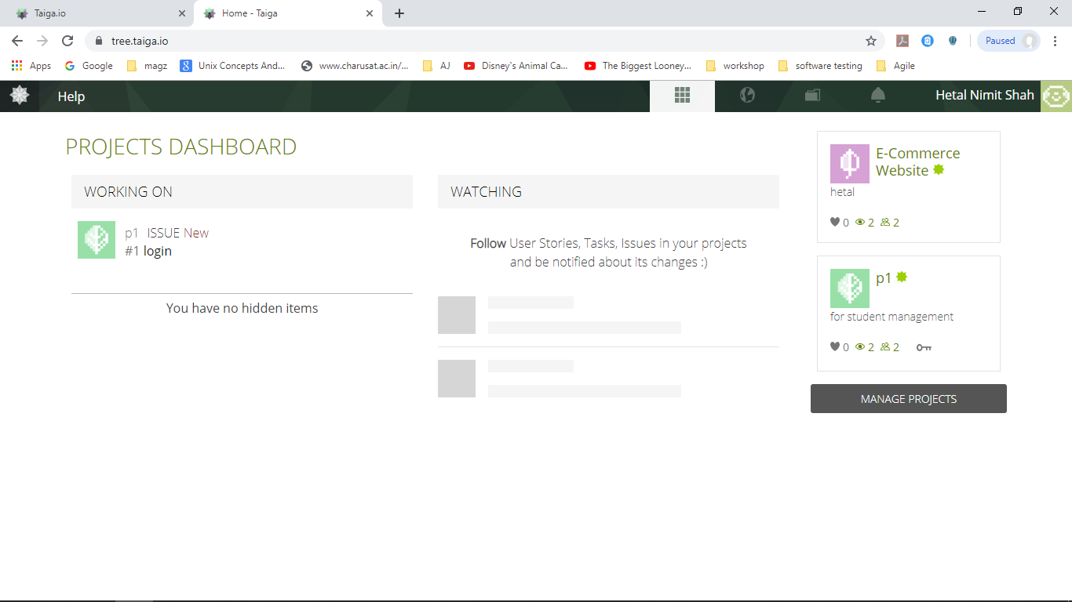

Create Project Menu:
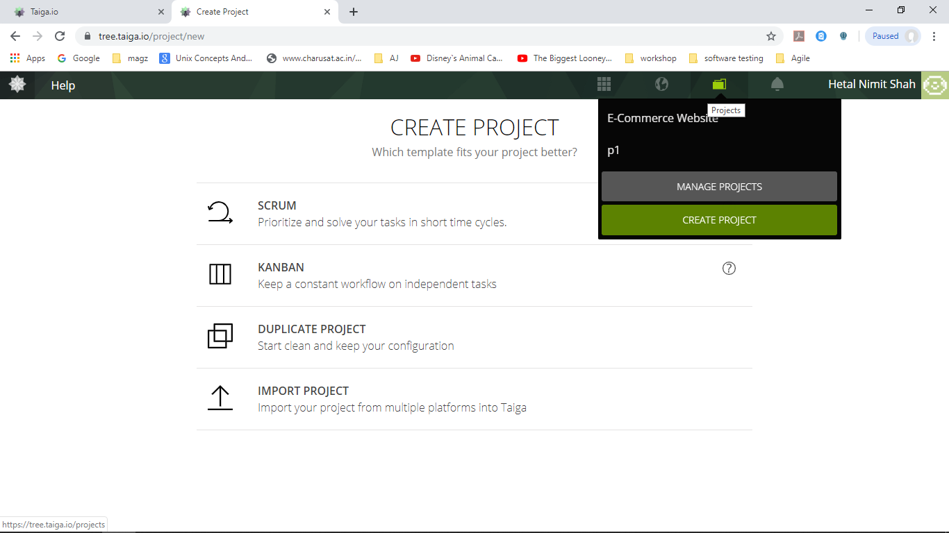
Scrum Project :
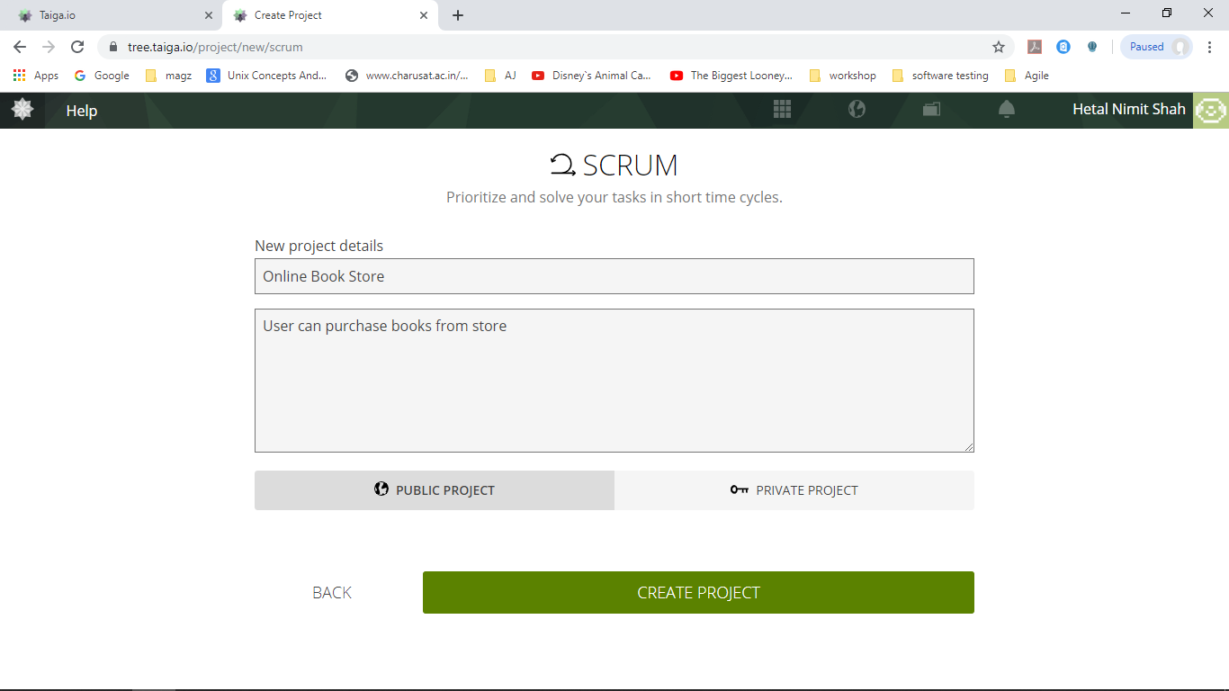
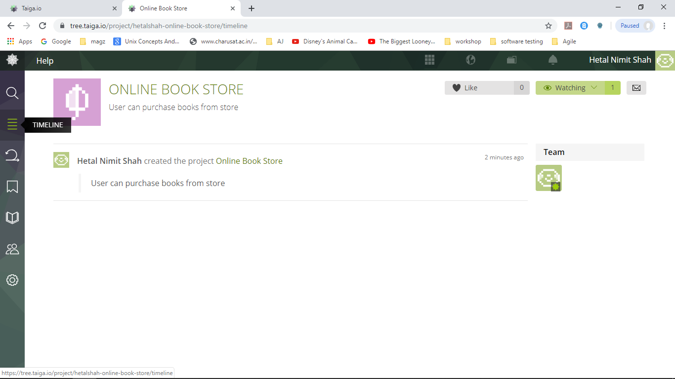
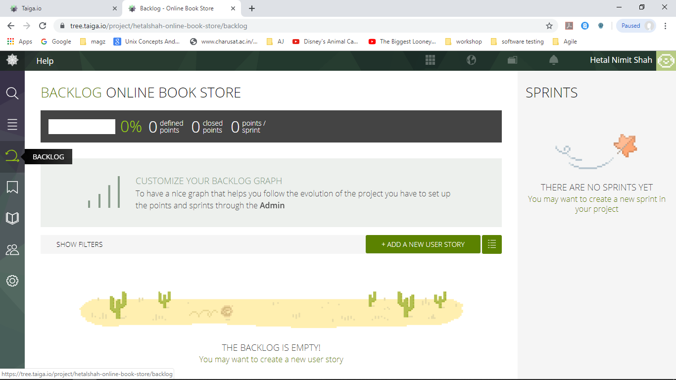
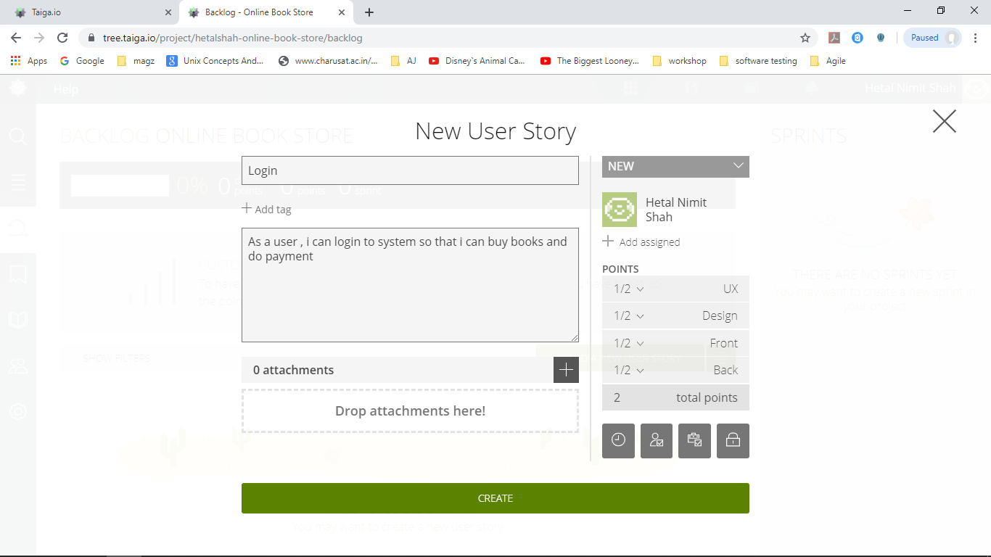
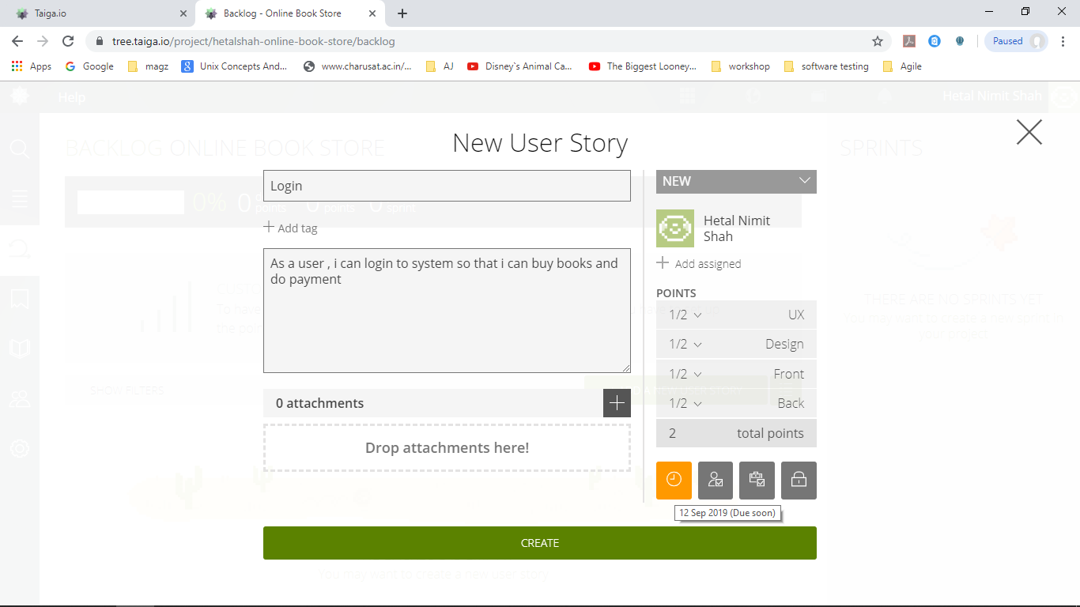
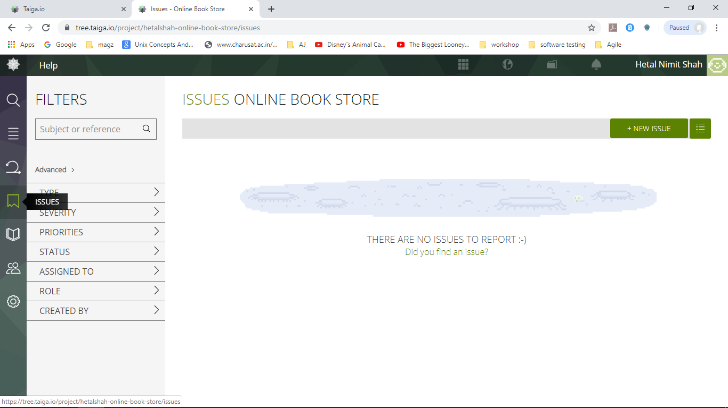
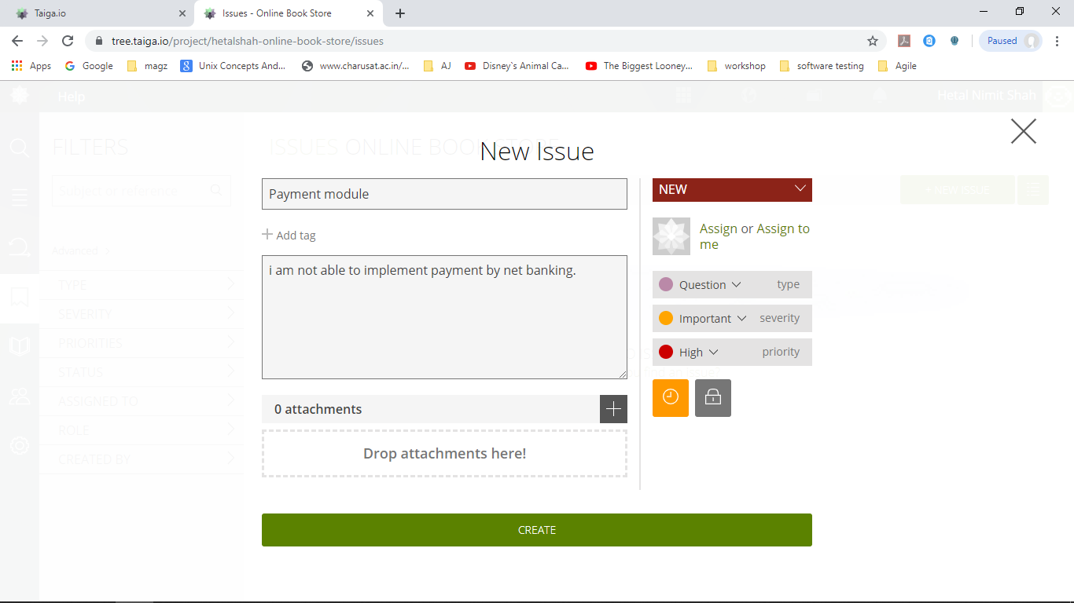

Sprint Creation
